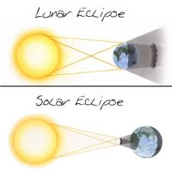
Solar and Lunar Eclipses

Fill in the table using the correct Standard Australian English. Only write in note form here!

 | Solar and Lunar Eclipses
Similarities | Involve the Sun, Earth and Moon.
Differences

Now use a complete sentence to tell me the similarities and differences.
You could use many different sentence structures to do this.
- Both solar and lunar eclipses have ……
- Solar and lunar eclipses are similar because ……
- A solar eclipse is like a lunar eclipse because ……

Similarities

Differences
Make your own sentence structure for the differences.



